**Four Hats of the President Activity:** Name:________________________ Date:________ Pd._____

**Directions:** Each picture and description is an example of the President performing his responsibilities under each of his four roles. After analyzing each picture and reading its description, you and your partner will decide which of the 4 roles it belongs to. Be ready to explain and defend your answer.

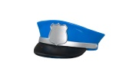**Chief Executive 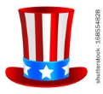 Head of State 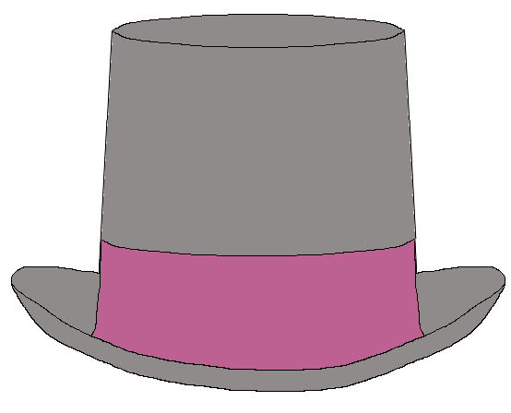 Chief Diplomat**  **Commander- in-Chief**

|  |  |
| --- | --- |
| **Example:** | **Which Hat/Role is being described?** |
| President Reagan throws out the first football at a game. |  |
| President Bush meets with troops. |  |
| President Carter meets with foreign leaders in Egypt. |  |
| President Clinton awards a medal of honor. |  |
| President Kennedy cuts a ribbon on a modern interstate highway. |  |
| President Nixon visits the Great  Wall of China on his trip to reopen diplomatic relations with China. |  |
| President Nixon welcomes Elvis  Presley to the White House. |  |
| President Lyndon B. Johnson greets  American troops in Vietnam. |  |
| President Clinton announces the appointment of Justice Ruth Bader Ginsburg to the Supreme Court. |  |
| President Gerald Ford meets with his Cabinet in the Cabinet Room, November 15, 1974. |  |

**Exit Ticket: On the back of this page, pick one of the four roles of president and design a hat for it.**



**President Reagan throws out the first football at a game.**



**President Bush meets with troops**.



**President Carter meets with foreign leaders in Egypt.**



**President Clinton awards a medal of honor.**



**President Kennedy cuts a ribbon on a modern interstate highway.**



**President Nixon visits the Great Wall of China on his trip to reopen diplomatic relations with**

**China.**



**President Nixon welcomes Elvis Presley to the**

**White House.**



**President Lyndon B. Johnson greets**

**American troops in Vietnam.**



**President Clinton announces the appointment of Justice Ruth Bader Ginsburg to the Supreme Court.**



**President Gerald Ford meets with his Cabinet in the Cabinet Room, November 15, 1974.**

**Two Truths and a Lie**

**One of the following statements is a lie. Which do you think it is?**

* **The President gets paid to throw large parties.**
* **The President can declare war if America's national security is threatened.**
* **The President has the power to appoint ambassadors.**