Foreign Policy Activity: Name:___________________ Date:__________ Pd._______
Directions: Read each situation below. Next to each situation, write which foreign policy tool was used (Foreign Aid, Military, Treaty).

 | Situation: | Foreign Policy Tool:
1. | More than 100 U.S. citizens died when the Germans sunk a passenger ship called the Lusitania in 1915, but President Wilson did not want to enter World War I. He convinced Germany to agree to stop the attacks.
2. | In 1917, Germany re-started its submarine attacks against unarmed ships even though it had pledged to stop. U.S. President Woodrow Wilson asked the U.S. Congress for a declaration of war, and the U.S. entered World War I.
3. | In 1940, Germany, Italy, and Japan signed an agreement forming an alliance. They hoped to keep the U.S. out of World War II. President Franklin Roosevelt asked Congress for aid to help Great Britain fight these powers.
4. | On December 7, 1941, Japan attacked Pearl Harbor, Hawaii. The next day, U.S. President Franklin Roosevelt asked the U.S. Congress for a declaration of war against Japan. Congress acted quickly, and the U.S. officially entered World War II.
5. | In order to defeat Germany in World War II, President Franklin Roosevelt worked with Great Britain to plan a major invasion of western Europe. In 1943, he appointed General Dwight Eisenhower to lead the attack.
6. | In 1949, after World War II, the United States and other democratic western countries formed NATO, the North Atlantic Treaty Organization. It said that if any country was attacked by an outside nation, they would help defend each other.
7. | After World War II, the United States gave more than $13 billion to help rebuild countries devastated by the war.
8. | During the Cold War, the United States was determined to stop communism from spreading. When communist North Korea invaded South Korea in 1950, President Truman sent U.S. troops to help stop the North Koreans.
9. | In 1968, the major countries of the world agreed to the “Nuclear Non-Proliferation…”
10. | In 1990, Iraqi leader Sadaam Hussein invaded and took over neighboring Kuwait. In January 1991, Congress authorized President George H. W. Bush to lead U.S. troops into Kuwait and force the Iraqi troops to leave.
11. | In 1993, the United States, Canada, and Mexico agreed to the North American Free Trade Agreement.
12. | On September 11, 2001, al-Qaeda terrorists attacked the United States. President George W. Bush asked Congress for authority to use military force against those responsible. U.S. troops were sent to Afghanistan, where al-Qaeda leaders were based.
13. | In January 2010, a terrible earthquake devastated Haiti. The United States sent food, water, doctors, and medical supplies.
14. | In 2013, the U.S. Agency for International Development’s “Water Supply, Sanitation & Hygiene” program in West Africa helped over 28,000 people get access to a better source for drinking water.

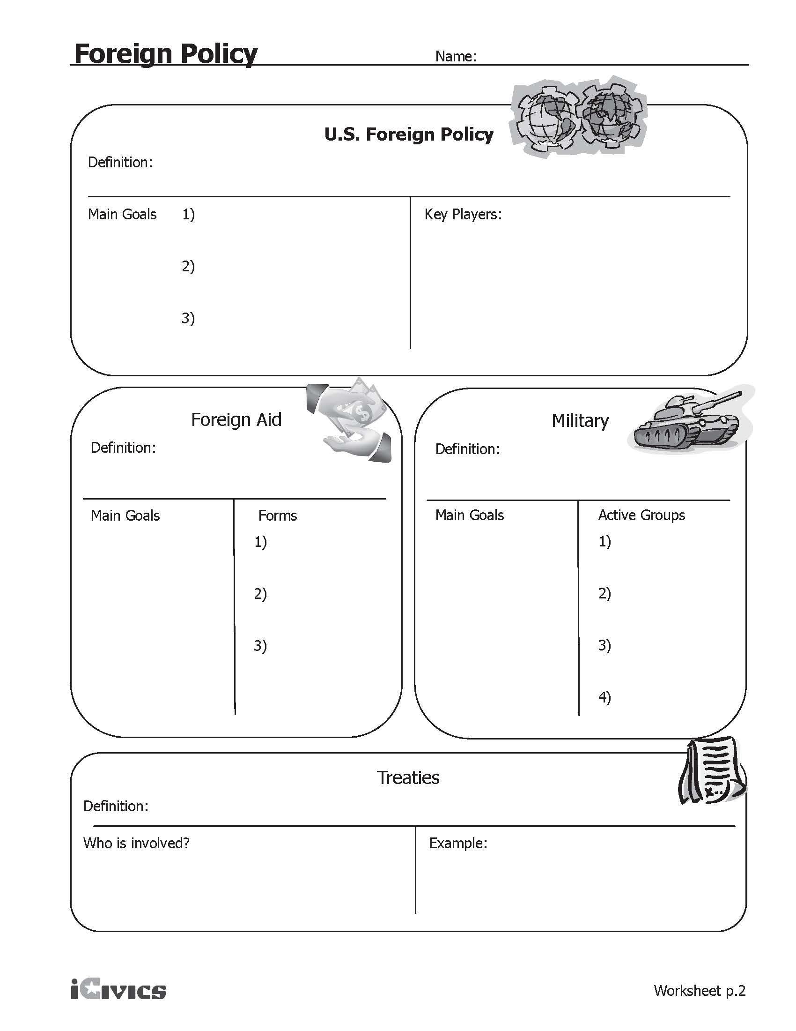
Our country’s ______________, words, and _________________ towards other countries.
The_____________ or assistance that we give to other _________________________.
This country’s _________________, led by our President who is called the ____________________-in-_________________
A formal ____________________between countries that, like laws, must be _______________
This treaty says that if ____________ of the countries is _____________________, the others will step in to _______________________ each other.

To ____________ war and ______________the United States.
1) Economic (______________)
2) Military (__________________ helping after a disaster)
3) Advice (like how to create a ____________________)

To create _____________________abroad
and create future _____________________ partners.

- The ___________________and ______________________ branch initiates foreign policy
- __________________ ____________ carries out foreign policy
4) Promoting “world _____________” to keep the U.S. ______________ and our trade flowing
3) Increase support for American _________ like democracy and _______________________
2) Support economic growth (____________) and human _____________ around the world
1) Protect _________________ and _______________________
1) _________________ America and Americans
2) Support economic growth (____________) and ______________ rights around the world

