Creating the Executive Branch
Would you want to be a U.S. president some day? You would have great power—and heavy responsibility. The president heads the executive branch of the national government. He or she is responsible for protecting the nation and its more than 310 million people, therefore many Americans look to the president as the person to take the lead in solving the nation’s problems.

The president is the manager, or director, of the federal government. The president’s job is to make sure that the government runs smoothly and that the laws of the land are enforced and obeyed by swearing to defend and protect the Constitution. Because of the power and global influence of the United States, the president may hold the most important job in the world.

- What is the purpose of the President? ______________________________________________________________________________________

What’s in the Constitution?

The President and the Vice-President are the only officials chosen by the entire country. Not just anyone can be President, though. The Constitution only lists three requirements to be President. In order to be elected, one must be at least 35 years old. Also, each candidate must be a natural-born U.S. citizen and have lived in the U.S. for at least 14 years.

Qualifications to be President
Age: | Citizenship Status: | Years of Residency:

When elected, the President serves a term of four years. Before 1951, the President could serve for as many terms as he wanted, but no one had tried. After two terms as President, George Washington chose not to run again. All other Presidents followed his example until Franklin D. Roosevelt. Roosevelt successfully ran for office four times but died early in his fourth term in 1945. Six years later, Congress passed the 22nd Amendment, which limits Presidents to two terms. Now, the most one President can serve is two terms, for a total of eight years.

- What effect did the 22nd amendment have on the term of a president? ______________________________________________________________________________________

Powers of the President
Article II of the Constitution created the executive branch. The list of powers it gives to the president is brief. These include the powers to:
- carry out and enforce laws made by Congress
- make treaties with foreign nations
- appoint certain important government officials (ambassadors, Supreme Court justices, cabinet members)
- act as commander-in-chief of the military
- veto laws passed by Congress
- pardon (forgive) people convicted of crimes against the United States.

The Constitution also requires, or calls for, the president to tell Congress about the “state of the union.” Each year, the president gives the State of the Union address. In this speech, the president discusses the nation’s most important issues and his or her plans to address them.

- Which of the above powers is an example of a check that the president has on another branch? ______________________________________________________________________________________

Checks on the Powers of the Executive Branch
The Constitution limits the powers of the executive branch by making it share most of its powers with Congress. Here are some examples of how this works.

- Appointments: The president has the power to nominate people for important jobs in government, like Supreme Court Justices, ambassadors, or members of his cabinet. However, he/she needs the consent, or approval, of the Senate because the Senate has the power to approve or reject the president’s nominations.
- Treaties: The president has the power to negotiate and create treaties with other countries, but the Senate has the power to approve or reject these treaties.
- War: Although the president can conduct a war as commander-in-chief, only Congress can declare war. In addition, only Congress has the power to provide money to conduct a war.
- Veto: The president may veto laws passed by Congress. Congress, however, may override the veto by a two-thirds vote of both houses.
- Impeachment: Congress has the power to impeach the president. To impeach means “to bring to trial.” This means the House can accuse the president of serious crimes or misconduct, then the Senate holds a trial. If the Senate finds the president guilty, he or she can be removed from office.

- Explain how Congress can check the power of the President when it comes to treaties.
____________________________________________________________________________________________________________________________________________________________________________
- Explain how Congress can check the power of the President when it comes to misconduct or serious crimes.
____________________________________________________________________________________________________________________________________________________________________________

The President’s Roles
Name:__________________________ Date: ______ Pd. _____
The President has many hats to wear. This means he has many different roles he must play in his position as President. Some of the President’s powers, or jobs, are listed in the U.S. Constitution. Other powers are implied (suggested as necessary) by U.S. laws, court decisions, or actions of earlier Presidents.
Chief Executive:
The president’s most important job is to carry out the nation’s laws. To do this, the president is in charge of 15 cabinet departments and many agencies. As the chief executive, the President is in charge of appointing people to head the departments and the agencies. About 3 million workers—not counting people in the armed forces—help carry out this work.
One tool presidents use to carry out the law is the executive order. An executive order is a rule or command the president gives out that has the same power and force as a law. Presidents use executive orders to spell out details of the policies set by Congress. They are part of the president’s duty to “take care that the laws are faithfully executed.” These orders also make it possible for presidents to act quickly when they must do so.
- What powers does the President have as the Chief Executive? ____________________________________________________________________________________________________________________________________________________________________________
One infamous example of a president’s executive order was the internment of Japanese-Americans during WWII. After the Japanese attacked Pearl Harbor, President Roosevelt issued E.O. 9066 which allowed for over 120,000 Japanese-American citizens to be taken from their homes, jobs, and schools and placed in internment camps where they lived for around 4 years out of “military necessity”. Later, it was found out that none of those who were placed in camps were connected in any way to the Japanese attacks.
Chief Diplomat:
The president leads the foreign policy (plan our country has to deal with other countries) of the United States. In this role, the president decides how the United States acts toward other countries. This role includes naming people to serve as ambassadors. These officials represent the United States government in other nations.
- What job does the president have in the role of Chief Diplomat? ____________________________________________________________________________________________________________________________________________________________________________
- What job do ambassadors have? _____________________________________________________________________________________
Head of State:
The president is the living symbol of the nation. In this role, he or she tries to build goodwill with other countries by greeting their leaders when they visit the United States. The president also represents all Americans at important ceremonies. For example, the president awards medals to the country’s heroes and places a wreath at Memorial Day ceremonies at Arlington National Cemetery.
- Describe the role of Head of State in your own words. ____________________________________________________________________________________________________________________________________________________________________________
Commander in Chief:
Under the Constitution, the president is commander in chief of the nation’s armed forces. This allows presidents to back up foreign policy decisions with force when they need to. The president and Congress share the power to make war. Congress has the power to declare war. Yet, only the president can order troops into battle. The commanders of the army, navy, air force, marines, and coast guard all follow the orders of the president.
Congress has declared war just five times. Presidents, however, have sent troops into action more than 150 times. For example, Congress never declared war on Iraq. Nonetheless, American troops invaded that nation in 2003 on orders of President George W. Bush.
- What is the difference in power between the Commander in Chief and the Congress when it comes to war? ____________________________________________________________________________________________________________________________________________________________________________
The President’s Cabinet
The president does not work alone. Thousands more people work in 15 large units called departments. The heads of those departments form the group of presidential advisers known as the cabinet. The head of the Department of Justice is called the attorney general. All other department heads are called secretaries. Over time, the cabinet grew into the 15 departments we see today. As you can see from the chart, the departments work in many different areas.
- Explain the cabinet__________________________________________________________________
- What are the heads of the departments called? _______________________________________
Department of State:  Plans and carries out the nation’s foreign policy | Department of Agriculture | Department of Transportation
Department of Homeland Security: oversees America’s defenses against terror attacks | Department of Health and Human Services | Department of Energy
Department of Defense: Manages the armed forces | Department of Labor | Department of Education
Department of Justice: Responsible for all aspects of law enforcement | Department of Commerce | Department of Veterans Affairs
Department of the Interior | Department of Housing and Urban Development | Department of the Treasury

Directions: See if you can match each of the President’s jobs, described below at left, with a real President’s action, listed below in the column at right.

A. President Richard M. Nixon visits China to improve relations with that country.
B. President George H.W. Bush entertains the Queen of England at the White House.
C. President John F. Kennedy issues an Executive Order to launch the Peace Corps.
D. President George W. Bush sends U.S. combat troops to Iraq.

____1. Chief Executive: The President enforces U.S. laws, creates policies, hires and fires officials within the executive branch, and appoints federal (national) judges. Congress must approve many appointments, including Cabinet Secretaries and Supreme Court Justices.

___2. Commander in Chief: The Constitution makes the President head of the nation’s military forces. Only
Congress can declare war, but recent Presidents have sent troops into combat without a formal declaration.

___3. Head of state: The President is a living symbol of the U.S. This job includes mostly ceremonial duties, such as welcoming foreign leaders, congratulating famous Americans, and promoting U.S. traditions.

___4. Chief Diplomat: The Constitution says that only the President can make treaties with other countries (although the Senate must approve them). The President, working with the Secretary of State, shapes policies for dealing with other countries.

Directions: See if you can match each of the President’s jobs, described below at left, with a real President’s action, listed below in the column at right.

A. President Richard M. Nixon visits China to improve relations with that country.
B. President George H.W. Bush entertains the Queen of England at the White House.
C. President John F. Kennedy issues an Executive Order to launch the Peace Corps.
D. President George W. Bush sends U.S. combat troops to Iraq.

____1. Chief Executive: The President enforces U.S. laws, creates policies, hires and fires officials within the executive branch, and appoints federal (national) judges. Congress must approve many appointments, including Cabinet Secretaries and Supreme Court Justices.

___2. Commander in Chief: The Constitution makes the President head of the nation’s military forces. Only
Congress can declare war, but recent Presidents have sent troops into combat without a formal declaration.

___3. Head of state: The President is a living symbol of the U.S. This job includes mostly ceremonial duties, such as welcoming foreign leaders, congratulating famous Americans, and promoting U.S. traditions.

___4. Chief Diplomat: The Constitution says that only the President can make treaties with other countries (although the Senate must approve them). The President, working with the Secretary of State, shapes policies for dealing with other countries.

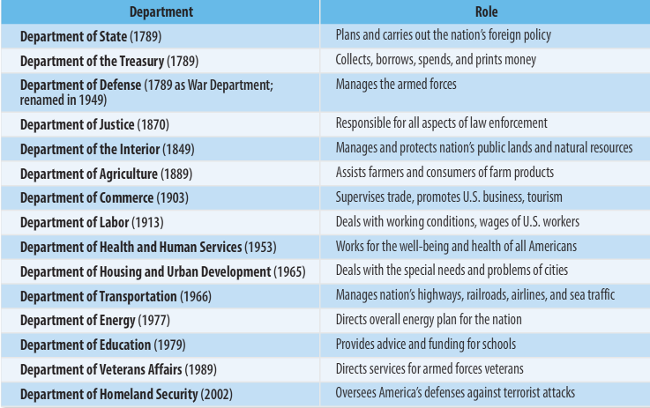
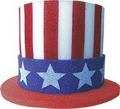
Chief Executive Chief of State
The President is a living symbol of the U.S. This job includes mostly ceremonial duties, such as welcoming foreign leaders, congratulating famous Americans, and promoting U.S. traditions.
The President enforces U.S. laws, creates policies, hires and fires officials within the executive branch, and appoints federal (national) judges.
Commander in Chief Chief Diplomat
The Constitution says that only the President can make treaties with other countries (although the Senate must approve them). The President, working with the Secretary of State, shapes policies for dealing with other countries.
The Constitution makes the President head of the nation’s military forces. Only Congress can declare war, but recent Presidents have sent troops into combat without a formal declaration.

