**Congress in a Flash! Name: _______________________________ Date:______________ Pd._________**

As you read, mark the text according to the key.

Circle the branch of government that makes the laws.

Put a box around the two chambers of Congress. Underline what it means to make laws.

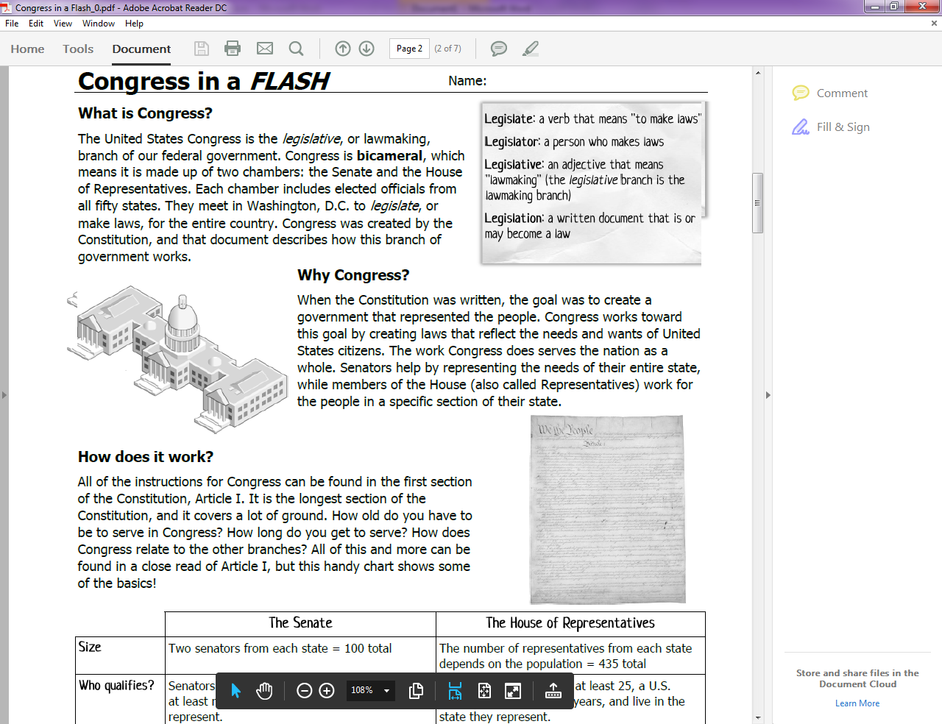

Circle the people Senators are responsible for representing.

Put a box around the people Representatives are responsible for representing.

Put a next to where Congress gets its directions from.



Underline things that Senators and Representatives have in common.

Circle things that *differ* between Senators and Representatives

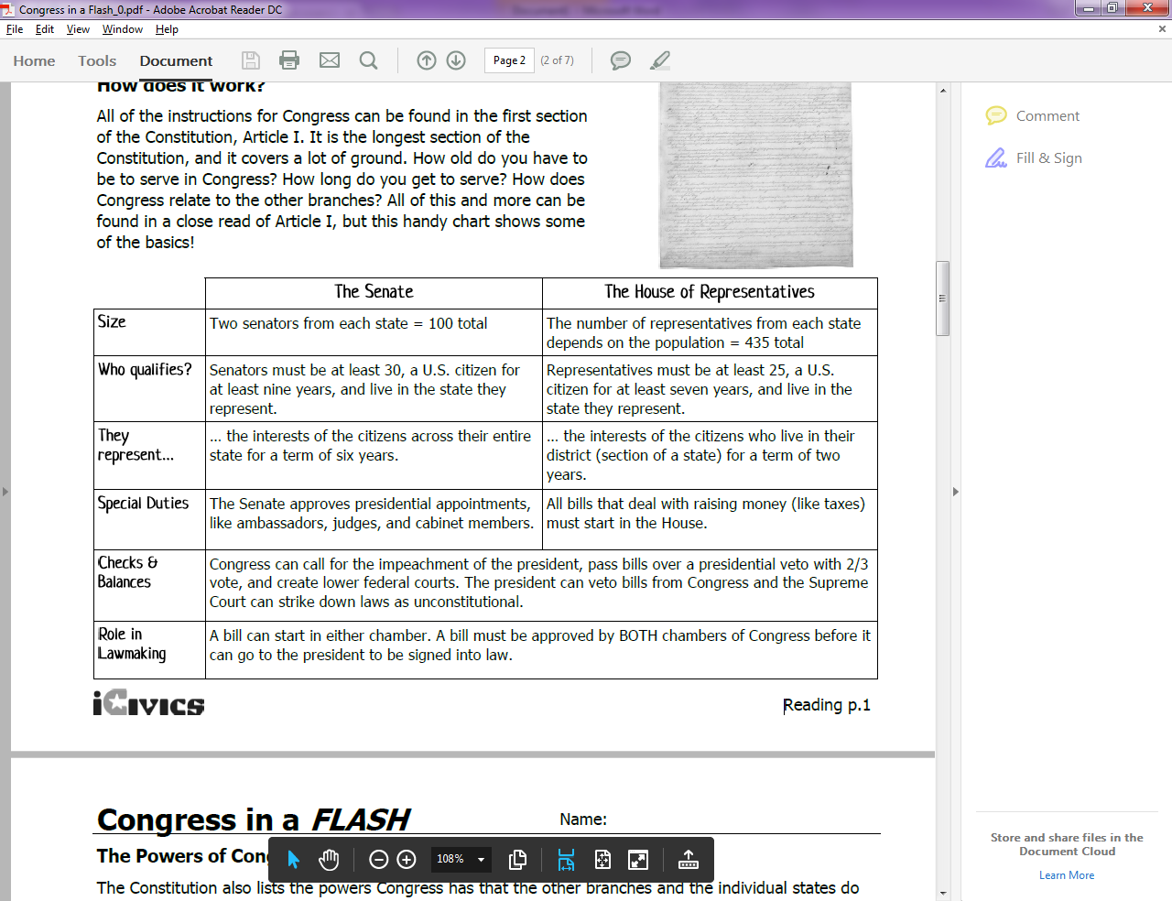

Number the top three powers you think Congress has. (#1 is most important, #3 is least)

